What can I do in 2022?
Four ways to plant trees for the planet

1. Plant a sapling or a seed
The Woodland Trust has a handy guide on how to plant a suitable tree on your land, which can be found here. If you don’t have any outdoor space yourself – or not enough – you could gift a sapling to a friend or family member who does. The Woodland Trust sells saplings through its online shop. Alternatively, you could try and germinate a seed.

2. Sponsor a Street Tree through Kingston Council
A more expensive option is to sponsor a Street Tree (£350) through a scheme run by Kingston Council (details can be found here). To make the price affordable, you could club together with others. Kingston Council also invites people to become Tree Wardens – volunteers who help look after trees on public land throughout the borough.

3. Pay a charity to plant a tree for you
For as little as £5, the National Trust or the World Land Trust will plant a sapling on land in their care.

4. Search with Ecosia
Make Ecosia your search engine and for every 45
searches you make (approx.), a tree will be planted!
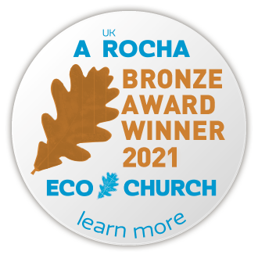
About this guide
We all want to do more to look after the environment.
But knowing where to start can be really tricky. That’s
why we made this guide – to help you do your bit
in 2022. If you found this guide handy, let us
know because we are looking to make more.
St Andrew and St Mark Church Eco Committee

